**Project proposal**

**EEY4189**

**GROUP PROJECT**

**PROJECT Title :-**

**road traffic management system**

**Group Name: Traffic24**

**Group Members:**

1. **M.M. Irfan (S92065814).**
2. **P. Komathy (S92065503).**
3. **P. Pirathapan (S92068465).**
4. **S. Thanujan (S18007700).**

**Contents:**

[**1. Executive Summary 3**](file:///C:\Users\DELL\Downloads\Project%20Proposal%20Template-updated%20in%202022.docx#_Toc17015345)

[**2. Product Description 4**](file:///C:\Users\DELL\Downloads\Project%20Proposal%20Template-updated%20in%202022.docx#_Toc17015346)

[**2.1. Problem we solve 4**](file:///C:\Users\DELL\Downloads\Project%20Proposal%20Template-updated%20in%202022.docx#_Toc17015347)

[**2.2. About the product 4**](file:///C:\Users\DELL\Downloads\Project%20Proposal%20Template-updated%20in%202022.docx#_Toc17015348)

[**2.3. Unique Features 5**](file:///C:\Users\DELL\Downloads\Project%20Proposal%20Template-updated%20in%202022.docx#_Toc17015349)

[**2.4. SWOT Analysis 6**](file:///C:\Users\DELL\Downloads\Project%20Proposal%20Template-updated%20in%202022.docx#_Toc17015350)

**[3. Market Analysis Draw the DFD 7](file:///C:\\Users\\DELL\\Downloads\\Project%20Proposal%20Template-updated%20in%202022.docx" \l "_Toc17015351)-8**

**3.1. Competitor Analysis 9**

[**5. Product Development 10**](file:///C:\Users\DELL\Downloads\Project%20Proposal%20Template-updated%20in%202022.docx#_Toc17015356)

[**5.1. Minimum Viable Product(MVP) 10**](file:///C:\Users\DELL\Downloads\Project%20Proposal%20Template-updated%20in%202022.docx#_Toc17015357)

[**6. Staffing and Operation 11**](file:///C:\Users\DELL\Downloads\Project%20Proposal%20Template-updated%20in%202022.docx#_Toc17015361)

[**6.1. Management Organization Chart/ Work distribution among team members 11**](file:///C:\Users\DELL\Downloads\Project%20Proposal%20Template-updated%20in%202022.docx#_Toc17015362)

**6.2. Operation Plan 12**

**7.** **Milestones and Reporting ………………………………………………………………….………………………13-14**

**8.Conclusion 15**

1. **Project Executive Summary**

As of the course EEY4189 Software Design in group we are form a group with four members. And we have been requested to do a project and before that we are planning to propose our project. In order that our project title was “Road Traffic Management”.

Nowadays the topic is that need to be talked about because traffic information differs from city to city, thus when dealing with a new city, how we can merge the original traffic technology with the new concept automatically is an important topic. We have proposed a framework for Traffic management system there are still many issues left for further development.

The main concept of traffic technology is on planning, designing, and implementing the transportation network, traffic control systems and public service in order to have smooth and efficient transportation and services.

1. **Product Description.**
   1. **Problem we solve**

The problem that we identified the terrible situation that we all ever face once in our life. That there is nothing worse thing than being trapped in our vehicle and waiting in the middle of a traffic jam. Traffic jams often occur during rush hour and it can also be caused by accidents who are violate the traffic ethics and rules which happened everywhere in the Island. So that the Traffic police cannot do their duties all the times.

**2.2 About the product**

In this project we have provided a summary of Traffic Department functional. When a tourist will come to our Island they don’t know where they go to the destination in short time without getting stuck in traffic and they don’t have much time to travel Whole Island in short term visit. Therefore our concept will help them not only tourist but also citizen of Sri Lankan as well.

In everywhere particular rush cities like Colombo, Kurunegala and kandy etc. these areas are too busy cities in this country. So that simply by visiting our web-based portal or mobile application (that we have plan to deploy) they got clear idea and avoid to stuck in traffic situation and will guided alternative clear and short root to the destiny.

By this project we have planning another option as well that, providing service by Motor Traffic Department by Issuing annual revenue vehicle License, Registration number reservation, Registration number gaining, Registering vehicle information with proper verified documents by uploading this system. Moreover in order to help Traffic police to install surveillance cameras in every traffic signal lights with motion sensor system. Those are who violate road rules and charge them automatically with capturing vehicle plat number.

* 1. **Unique Features**

Our proposed Road Traffic management Systems collect and analyzed driving information of vehicles in the area, perform the optimal traffic signals in accordance with the constantly changing road traffic situation and provide useful traffic information to drivers based on the data collection.

Ensuring a smooth traffic flow by compression the driving time of vehicles and reducing the number of times vehicles come to a halt will lead to benefits such as a reduction in road traffic accidents and a decrease in air pollution, which will in turn make a significant contribution to a safe and comfortable road traffic environment.

We decide to introduce colorful display information boards by using projectors that allow user awareness.

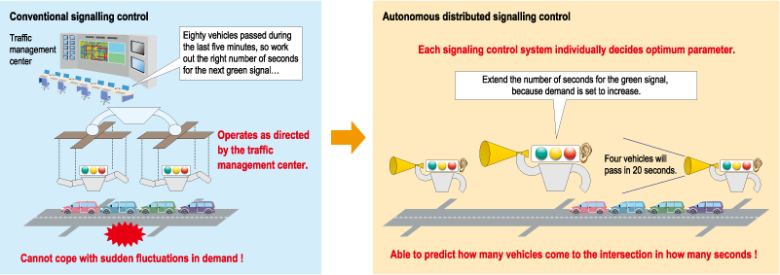

Figure 1: Signal Control Function

**2.4 SWOT Analysis**

SWOT analysis is one of the most straightforward approaches that can be used in the analysis of a project’s strategic position. It includes factors of internal strengths and weaknesses, as well as external opportunities and threats.

This research project provides a unique and multidisciplinary overview of Traffic Management system modes in the region that is necessary for future quantitative investigations. Furthermore, it introduces the steps to analyze transportation modes of other areas and regions.

We propose the following steps to analyze transportation modes of areas and regions:

1. Identifying the SWOT factors: brainstorming, SWOT form, interview, and literature review can be applied to identify strengths, weaknesses, opportunities, and threats factors.
2. Ranking the factors: multifactor process and pairwise comparisons are utilized to rank the identified factors.
3. Calculating the average of the weights for each factor:
4. Transportation strategies: transportation strategies related to the identified strengths, weaknesses, opportunities, and threats in the region are defined by the experts.

Weakness:

1. Less knowledge of Road Rules
2. Non-skilled person for marketing
3. Limited access
4. No branding
5. Related to Government site

Strength:

1. Technological innovative idea
2. Free registration
3. Easy to make to-do-list
4. Quickly respond for violators

Treats:

1. Lack of information sharing
2. No previous knowledge
3. Lack of building complexes for start up

Opportunities:

1. Future development
2. Increasing foresight
3. Collaboration
4. Exposure to expertise on the industry
5. **Market Analysis**

DFD Diagram

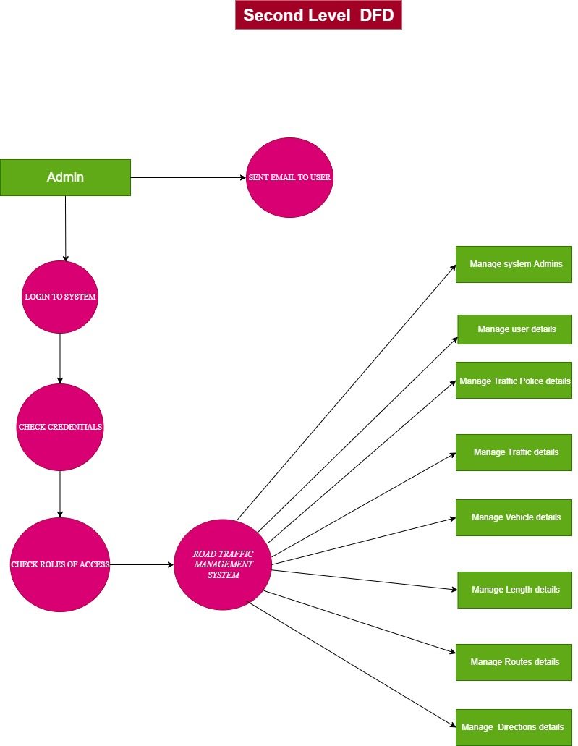

**3.1 Competitor Analysis**

|  |  |  |  |  |
| --- | --- | --- | --- | --- |
| **Features** | **Traffic24** | **Motor traffic** | **viamichelin** | **sciencedirect** |
| Not Private(SSL) | Yes | No | Yes | Yes |
| User Friendliness | Yes | Yes | No | Yes |
| Push notifications | Yes | Yes | Yes | No |
| Admin | Yes | No | No | No |
| Suggest places | Yes | Yes | No | Yes |
| Analytics | Yes | No | Yes | Yes |

**5. Product Development**

**5.1** Minimum Viable Product(MVP)

In a software industry the MVP will help project team to get feedback how quick as possible from the users to iterate and improve the product. The MVP is a kind of product that developed by software teams which include enough features to attract customers and validate the product idea in the early product development cycle.

Our project fully based on direct user interaction system. Therefore our priority is how to attract user and they must feel the User Experience (UX) as well as User Interface (UI) by use of our interface.

We estimate to release our product on **1st of November 2022** this is not for earning but also gathering feedback and comments from the user in order to improve our development process. In this MVP we includes the following features

1. User Can Login to the system or Sign Up for free
2. User can register for first registration for vehicle, Transfer ownership etc.
3. Traffic status: Live road map direct linked with google road map it help user can assume the rout selection for best way
4. Most of us don’t know road ACT and LAW it included in all three languages
5. Online violation tariff checking facilities

1. **Staffing and Operation**

6.1 Management Organization chart / Work distribution among team members.

|  |  |  |  |  |  |  |
| --- | --- | --- | --- | --- | --- | --- |
| members | Activity | 1stmonth | 2nd month | 3rd month | 4th month | 5th month |
| (Octobrt) | (November) | (December) | (January) | (February) |
| All members | **Project Proposal**  **Project idea**  **Existing problem,**  **Propose Solution** |  |  |  |  |  |
| M.M. Irfan  P.komathy | **Requirements analyst** |  |  |  |  |  |
|  | **Implementation** |  |  |  |  |  |
| P. Pirathapan | **Revised Architectural Diagram,** |
| S. Thanujan | **Revised UML Diagrams** |
| P.komathy | **Progress of the implementation** |
| M.M. Irfan | **Test Case Document** |
| P. Pirathapan  S. Thanujan | **System Design**  **(UI, UX)** |  |  |  |  |  |
| P. Pirathapan | **Development of system (coding)** |  |  |  |  |  |
| All members | **Integration,**  **Test Results and Submission** |  |  |  |  |  |
| All members | **Final presentation** |  |  |  |  |  |

1. **Milestones and Reporting**

|  |  |  |  |
| --- | --- | --- | --- |
| **Milestone** | **Responsibility** | **Milestone Deliverables** | **Deliverable Date** |
| **Milestone 3 : Project Proposal Submission** | **submission as a softcopy** | **Proposal:**  **review (3-5 relevant research papers),**  **Existing Problem,**  **Propose Solution,**  **Technology planning to use** | **3rd October 2022** |
| **Milestone 4 : Software Requirement Specification(SRS)** | **submission as a softcopy** | **Software Requirement Specification(SRS) document** | **3rd November 2022** |
| **Milestone 5 : Progress Review Presentation** | **10 min Presentation** | **10 min Presentation:**    **Project idea,**  **SRS,**  **Design,**  **Test Plan** | **2nd,3rd,4th,5th December 2022** |
| **Milestone 6: Intermediate Report Submission** | **report submission as a softcopy** | **Report:**  **Revised Architectural Diagram,**  **Revised UML Diagrams,**  **Progress of the implementation,**  **Test Case Document,**  **Appendix (Reflective journal, Meeting minutes)** | **31st December 2022** |
| **Milestone 7: Final Report Submission** | **report submission as a softcopy** | **Report:**  **Background of the Project,**  **Literature Survey & Competitor Analysis,**  **Design,**  **Development,**  **Test Results,**  **Appendix (SRS, Design Document, Reflective journal, Meeting minutes),**  **Conclusion** | **15th January 2023** |
| **Milestone 8: Final presentation** | **Completed project** | **10 minutes presentation** | **4th,5th,6th,7th February 2023** |

1. **. Conclusion**

Traffic jam is a very serious issue in every city that causes several problems for common man. It consumes so much of time and energy unnecessarily and hence the loss of the nation. Therefore, serious measures have to be taken by the authorities to control traffic and promote the use of public transport. Development of public transport network at economical rates is essential. Implementation of traffic safety rules by traffic police is a must.People should drive more sensibly and responsibly. Hence we all can work in this way to solve the big threat of the current time.

**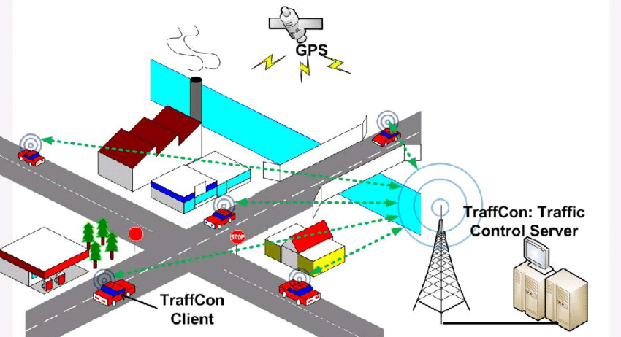**

**Thank you.**